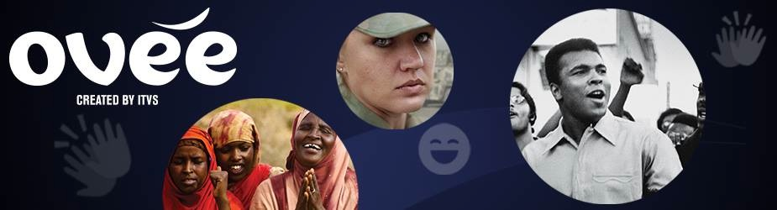
RUN OF SHOW TEMPLATE
BEFORE THE EVENT
Thanks for joining us early. We’ll get started momentarily.
In the meantime, use the social media share buttons to invite your friends to this event.
To our panelists, please enter a message in the chat to let us know you have arrived.
POLL: Is this your first OVEE screening event?
Yes
No
I’m not sure
<play preview content if applicable>
START OF EVENT
Welcome to OVEE, a virtual theater that allows you to watch together and chat live with friends, fans and experts. Let’s start the show.
Today we are watching <film or videos>.
This event is presented by <your organization(s)>.
We are pleased to introduce our panelists for today’s live chat.
<name and one-sentence bio for each of your panelists>
Our panelists are here to answer your questions. We invite you to type questions and comments into the chat box.
You can also use the emoticons under the video player to express yourself.
Please take our poll questions by clicking on the question mark above the chat.
POLL: How did you hear about today’s event?
from a friend
television
radio
flyer
at an event
website
social media
DURING THE EVENT
<5-10 questions for your panelists>
<3-5 questions to pose to your audience>
<3-5 facts about the topic>
<2-3 polls related to the content or impact goals>
<5-10 links to videos, articles, resources or organizations>
END OF EVENT
POLL: What impact has today’s event had on you? Choose the one that most applies.
I learned new information
I became inspired to get involved
I found a new resource to use
I made a connection with someone
All of the above
None of the above
Thank you for participating in today’s discussion.
We invite you to stay connected with us at <enter links to email or social media here>.
A special thank you to our panelists <enter name here>.
And to our partners <enter names here>.
<under the Actions button, click end screening>

