#SheDocs Online Film Festival: March 1 - 31, 2014
Throughout the month of March, Women and Girls Lead and Eileen Fisher, Inc. celebrate Women’s History Month by launching #SheDocs, an online film festival showcasing 12 documentaries that highlight extraordinary women and their accomplishments. This month-long festival presents a collection of films by prominent independent filmmakers that focus on women and girls who are transforming their lives, their communities, and the world. There is no other online film festival that brings documentary film about women and girls to U.S. online audiences for free!

Watch the films online, host a screening, and join the movement! Visit us at womenandgirlslead.org and be inspired by remarkable and true stories about women and girl agents of change!

Embeddable Trailer: bit.ly/SheDocs_Trailer

Facebook Posts:
- Celebrate Women’s History Month with the #SheDocs online film festival! Watch, host, or share 12 free documentaries from @WomenGirlsLead all month long. #SheDocs is sponsored by @EILEENFISHER. bit.ly/SheDocs2014
- The 2nd annual #SheDocs online film festival is happening now! You have until March 31st to watch 12 free films showcasing women who are rising into leadership and defying odds. bit.ly/SheDocs2014

Twitter Posts:
- #SheDocs online film festival sponsored by @EILEENFISHER is happening now! Watch 12 free films until 3/31: bit.ly/SheDocs2014 #WHM
- Celebrate Women’s History Month w/ @WomenGirlsLead & the #SheDocs film festival! Watch 12 films for free online: bit.ly/SheDocs2014 #WHM
- Visit the #SheDocs online film festival before March 31st for 12 free films to watch during Women’s History Month bit.ly/SheDocs2014
- All month long, @EILEENFISHER @WomenGirlsLead bring you documentaries showcasing incredible women: bit.ly/SheDocs2014 #SheDocs

Blog About #SheDocs!

Share your thoughts and spread the word about:

- #SheDocs
- Women’s History Month
- International Women’s Day - March 8th
The United Nations 2014 Theme: Inspiring Change
- #SheDocs films that inspired change and encouraged
you to take action
- Extraordinary women and girls who affected your life
- Positive media representations of women and girls

For more information, visit womenandgirlslead.org
or contact Kristy Chin at kristy_chin@itvs.org.

#SheDocs is sponsored by:

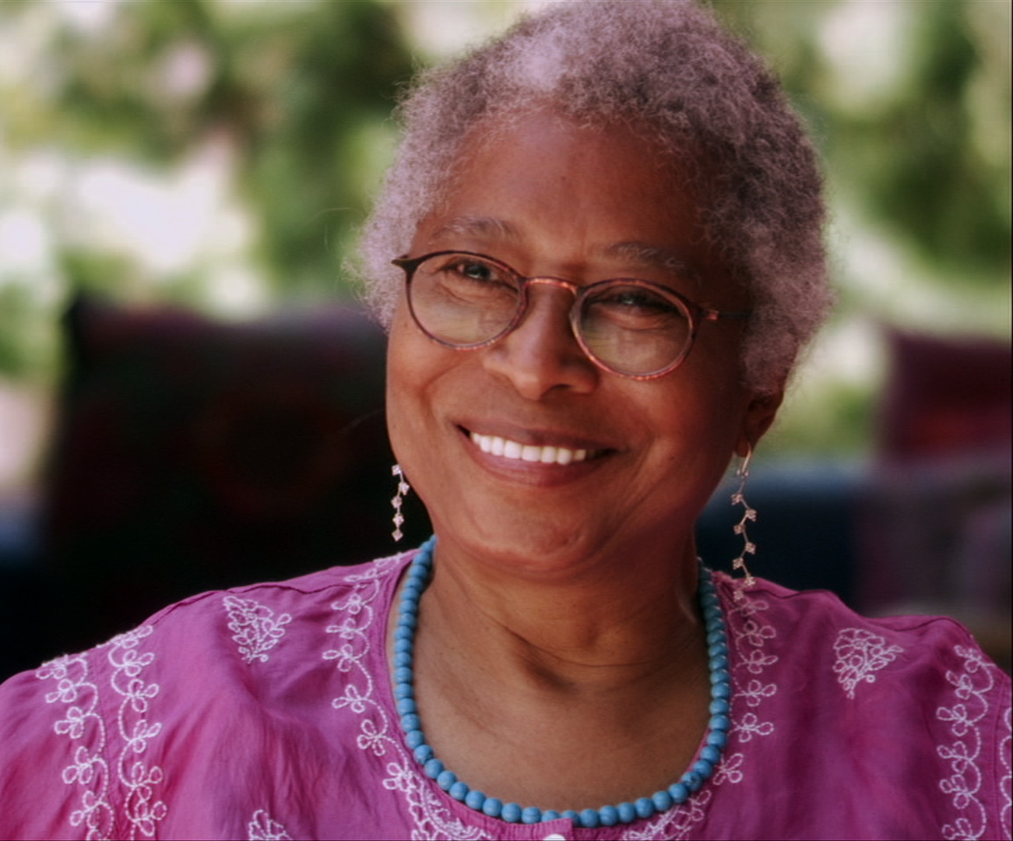

#SheDocs Kick-off Event!
Alice Walker: Beauty in Truth
Watch and Chat Live – March 3rd, 6pm ET
PBS series American Masters, in partnership with Women and Girls Lead, present a special online
social screening of Alice Walker: Beauty in Truth, as part of our official launch of the #SheDocs online
film festival. Join us for an exciting online conversation with special guests and fans nationwide!
Facebook Post
Take a penetrating look at the life and art of Alice Walker, a self-confessed renegade and human rights activist. #SheDocs online film
festival launches with Alice Walker: Beauty In Truth. Save the date for a special online social screening, March 3, 6pm ET. Chat with special guests and fans nationwide! bit.ly/1buq2Eh
Twitter Post
Alice Walker: Beauty in Truth kicks off the 2nd annual @WomenGirlsLead #SheDocs film fest. Watch/chat online 3/3 6pET: bit.ly/1buq2Eh

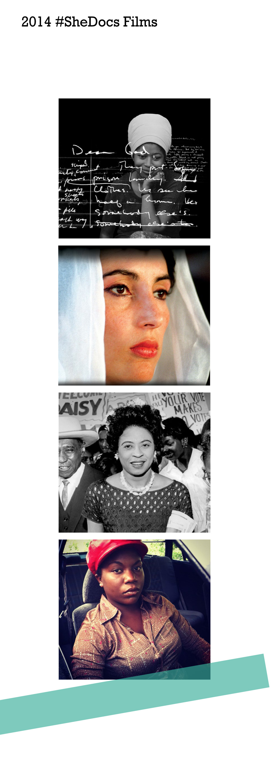

ALICE WALKER: BEAUTY IN TRUTH
Facebook Post
Alice Walker: Beauty In Truth offers audiences a penetrating look at the life and art of an artist, a self-confessed renegade, and human rights activist.

Watch the documentary for free until March 31st as part of the @WomenGirlsLead #SheDocs online film festival: http://to.pbs.org/LLTdGK
Twitter Post
Watch Alice Walker: Beauty in Truth online in the #SheDocs film fest throughout Women’s History Month: http://to.pbs.org/LLTdGK #WHM

Bhutto
Facebook Post
Celebrate Women’s History Month by watching Bhutto, the story of the first woman elected to lead an Islamic nation.

The inspiring documentary is available all month long in the @WomenGirlsLead #SheDocs film festival: bit.ly/SheDocs2014
Twitter Post
Bhutto is the story of the first woman elected to lead an Islamic nation. Watch online through 3/31: bit.ly/SheDocs2014 #SheDocs #WHM

Daisy Bates: The First Lady of Little Rock
Facebook Post
Daisy Bates was a complex, unconventional, and largely forgotten heroine of the civil rights movement who led the charge to desegregate the all-white Central High School in Little Rock, Arkansas in 1957.

Watch the documentary Daisy Bates: First Lady of Little Rock, throughout Women’s History Month in the #SheDocs online film festival: http://to.pbs.org/1azkb05

Twitter Post
Witness the story of Daisy Bates, a heroine of the civil rights movement. #SheDocs online film festival: http://to.pbs.org/1azkb05 #WHM

Good Country People
Facebook Post
What happens when a woman does a “man’s” job? Find out in Good Country People, a featured documentary short in the @WomenGirlsLead #SheDocs film festival. Watch online through March 31st: http://to.pbs.org/LBXmNv

Twitter Post
What happens when a woman does a “man’s” job? Watch Good Country People online at #SheDocs film fest through 3/31: http://to.pbs.org/LBXmNv

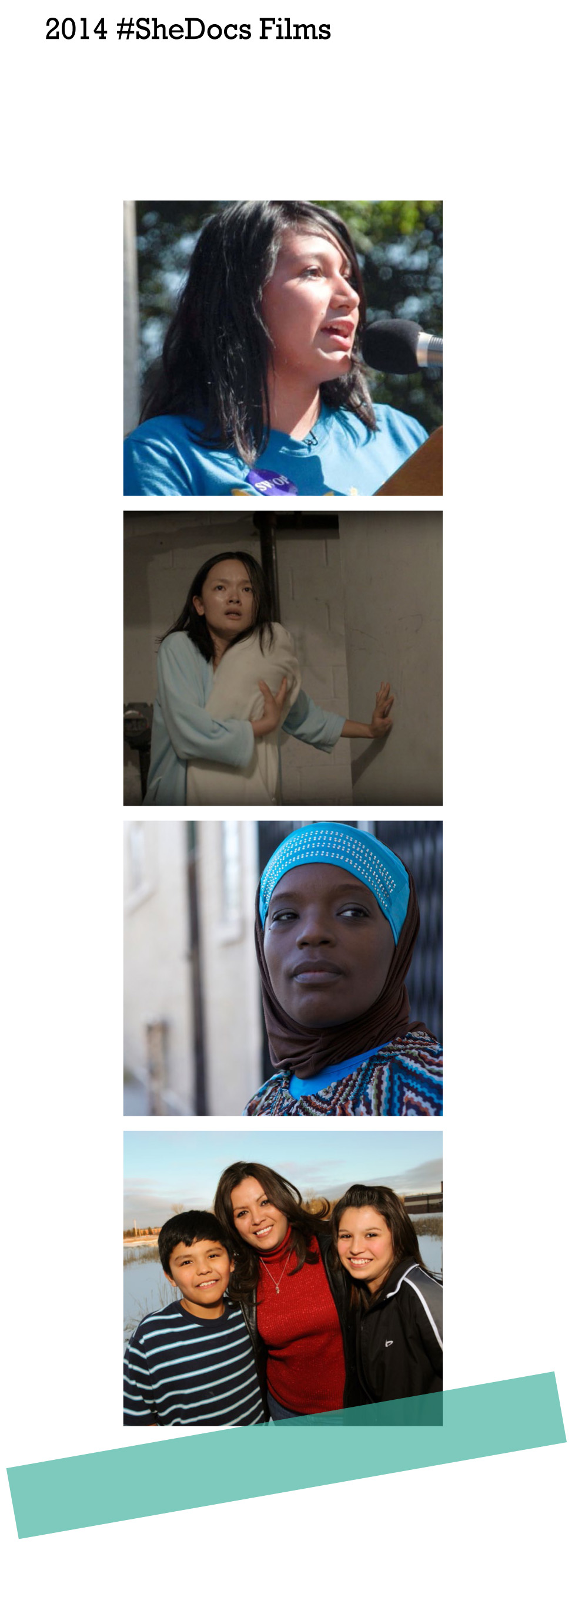

The Graduates: Girls Hour
Facebook Post
Over-crowded schools. Teen pregnancy. Pressure to contribute to family finances.

The Graduates: Girls Hour explores the dropout crisis from the perspective of three Latinas who are having a say in their own futures. Watch online through March 31st in the second annual #SheDocs film festival: http://to.pbs.org/1nXbss5

Twitter Post
Meet #TheGraduates, three Latinas who refuse to be just another statistic. Watch through 3/31 http://to.pbs.org/1nXbss5 #SheDocs

Half of Her
Facebook Post
Mei gives birth to a child in New York City’s Chinatown. When her father discovers the baby is a girl, he tries to force Mei to abandon her.

Mei’s story is told in Half of Her -- a short film that is part of a special @WomenGirlsLead collection of international stories made for and by women. Watch for free during the #SheDocs online film festival: http://to.pbs.org/1cZaGGJ

Twitter Post
Half of Her is part of a film collection made for women, by women. Watch online #SheDocs film festival: http://to.pbs.org/1cZaGGJ #WHM

The Interrupters
Facebook Post
Originally premiering on @Frontline, “The Interrupters” is the story of three “violence interrupters,” including the amazing Ameena Matthews, who with bravado, humility, and even humor try to protect their communities from the violence they once employed.

Watch for free until March 31st in the #SheDocs film festival. http://to.pbs.org/1fWPQrA

Twitter Post
For a limited time only, watch @TheInterrupters online as part of the
@WomenGirlsLead #SheDocs film fest: http://to.pbs.org/1fWPQrA #WHM

Kind Hearted Woman
Facebook Post
Can you heal from the wounds of abuse? Kind Hearted Woman follows one single mother’s intimate journey to find hope and a better life for her family.

Originally premiering on @Frontline & @IndependentLens, this fan-favorite film is now available online in the @WomenGirlsLead #SheDocs film festival.
Part 1: http://to.pbs.org/1ndNPZ4. Part 2: http://to.pbs.org/N9iRab

Twitter Post
Follow a mother’s intimate journey to heal from abuse. #KindHeartedWoman avail online until March 31st http://to.pbs.org/1ndNPZ4 #SheDocs

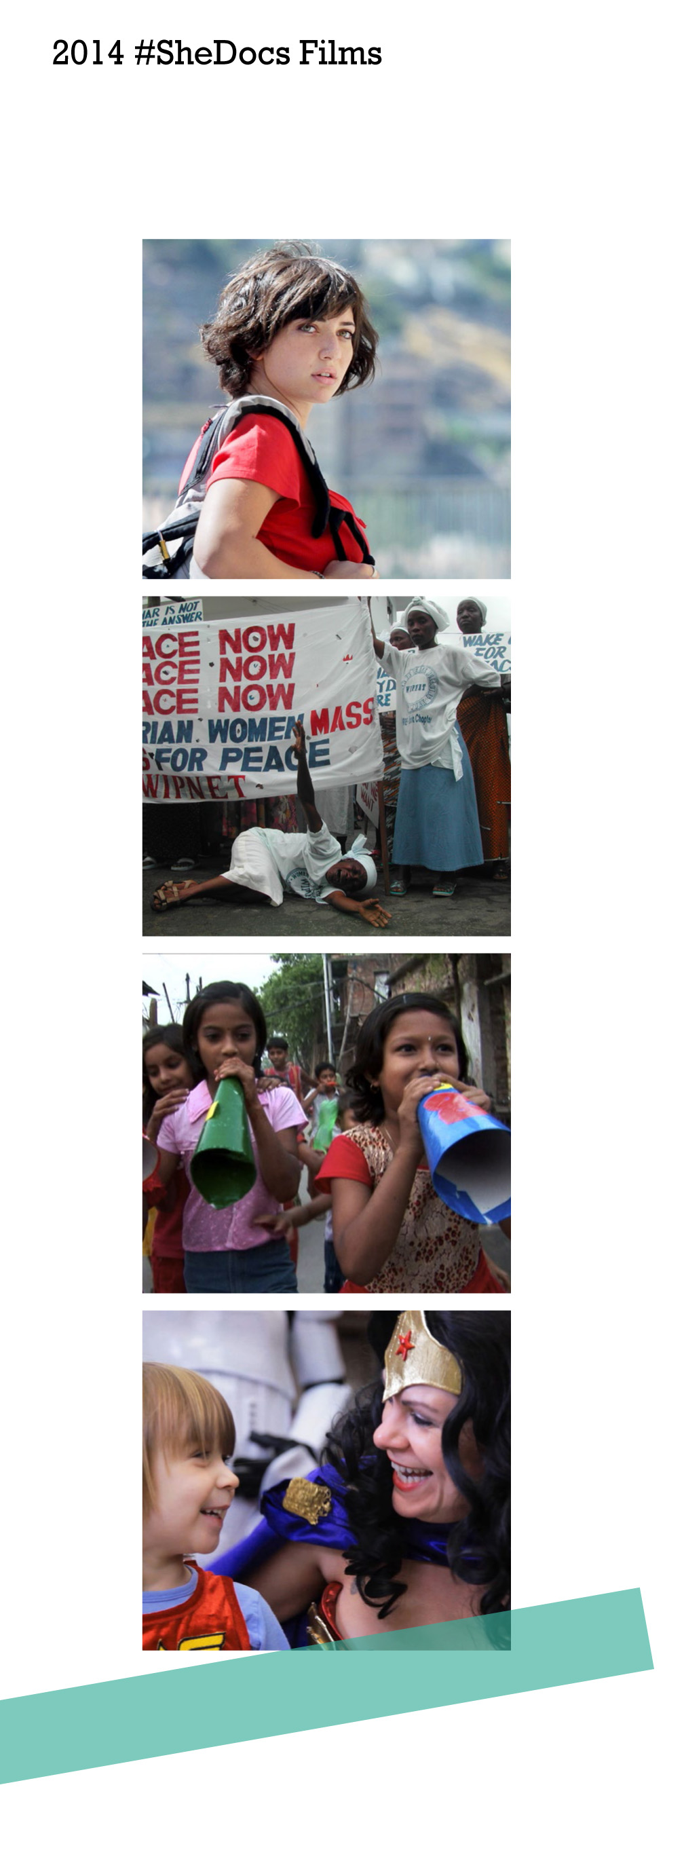

Not Another Word
Facebook Post
Not Another Word is an intimate portrait of three generations of women in a Middle Eastern family with deeply conflicted values. It is part of a collection of short films exploring international stories made for and by women.

Watch it for free until March 31st in the #SheDocs Film Festival: http://to.pbs.org/1b5GyL4

Twitter Post
Watch Not Another Word, which follows a family w/ deeply conflicted values. #SheDocs online Film Festival: http://to.pbs.org/1b5GyL4

Pray the Devil Back to Hell
Facebook Post
Pray the Devil Back to Hell is the astonishing story of the Liberian women who took on the warlords and regime of a dictator in the midst of a brutal civil war, and won a once unimaginable peace for their shattered country in 2003.

Watch the documentary until March 31st in the @WomenGirlsLead #SheDocs online film festival: http://to.pbs.org/1gQvh3M

Twitter Post
Pray the Devil Back to Hell, an example of how one woman can alter the history of nations. Watch online: http://to.pbs.org/1gQvh3M #SheDocs

The Revolutionary Optimists
Facebook Post
“If you want to start any type of change, start it with the children.”
Don’t miss The Revolutionary Optimists, a documentary about child activists bringing about change in their communities. Watch online through March 31st in the @WomenGirlsLead #SheDocs film festival: bit.ly/SheDocs2014

Twitter Post
What if you refused to accept your fate? Don’t miss @RevOptimists in the @WomenGirlsLead #SheDocs #FilmFest bit.ly/SheDocs2014

Wonder Women! The Untold Story of
American Superheroines
Facebook Post
What better way to celebrate Women’s History Month than by watching Wonder Women! The Untold Story of American Superheroines! The documentary, which originally premiered on @IndependentLens, is available online until March 31st in the @WomenGirlsLead #SheDocs Film Festival: bit.ly/SheDocs2014

Twitter Post
What’s your superpower? Celebrate #WHM & watch @WonderWomenDoc in the #SheDocs film festival until 3/31: bit.ly/SheDocs2014

