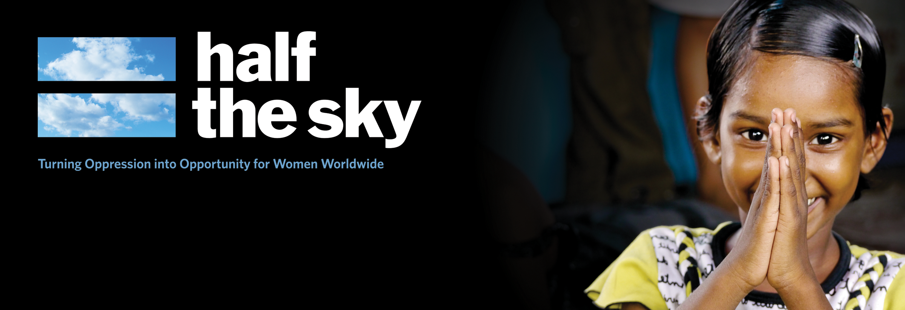

Inspired by the best-selling book, Half the Sky: Turning Oppression into Opportunity for Women Worldwide follows authors Nicholas Kristof and Sheryl WuDunn, and celebrity actresses across the globe to tell the stories of inspiring, courageous individuals creating change for women and girls everywhere.
Half the Sky: Turning Oppression into Opportunity for Women Worldwide is a special presentation of Independent Lens broadcasting on PBS October 1st and 2nd, 2012. Learn more at pbs.org/independentlens/half-the-sky.
TAKE ACTION
Visit halftheskymovement.org to learn more about the film, the book, and the partners.
[Insert your action items here.]

[Insert your logo here]
SHARE YOUR COMMITMENT
1. Write down your commitment to take action
2. Take a photo with it
3. Post to your social media page
4. Tag Half the Sky

