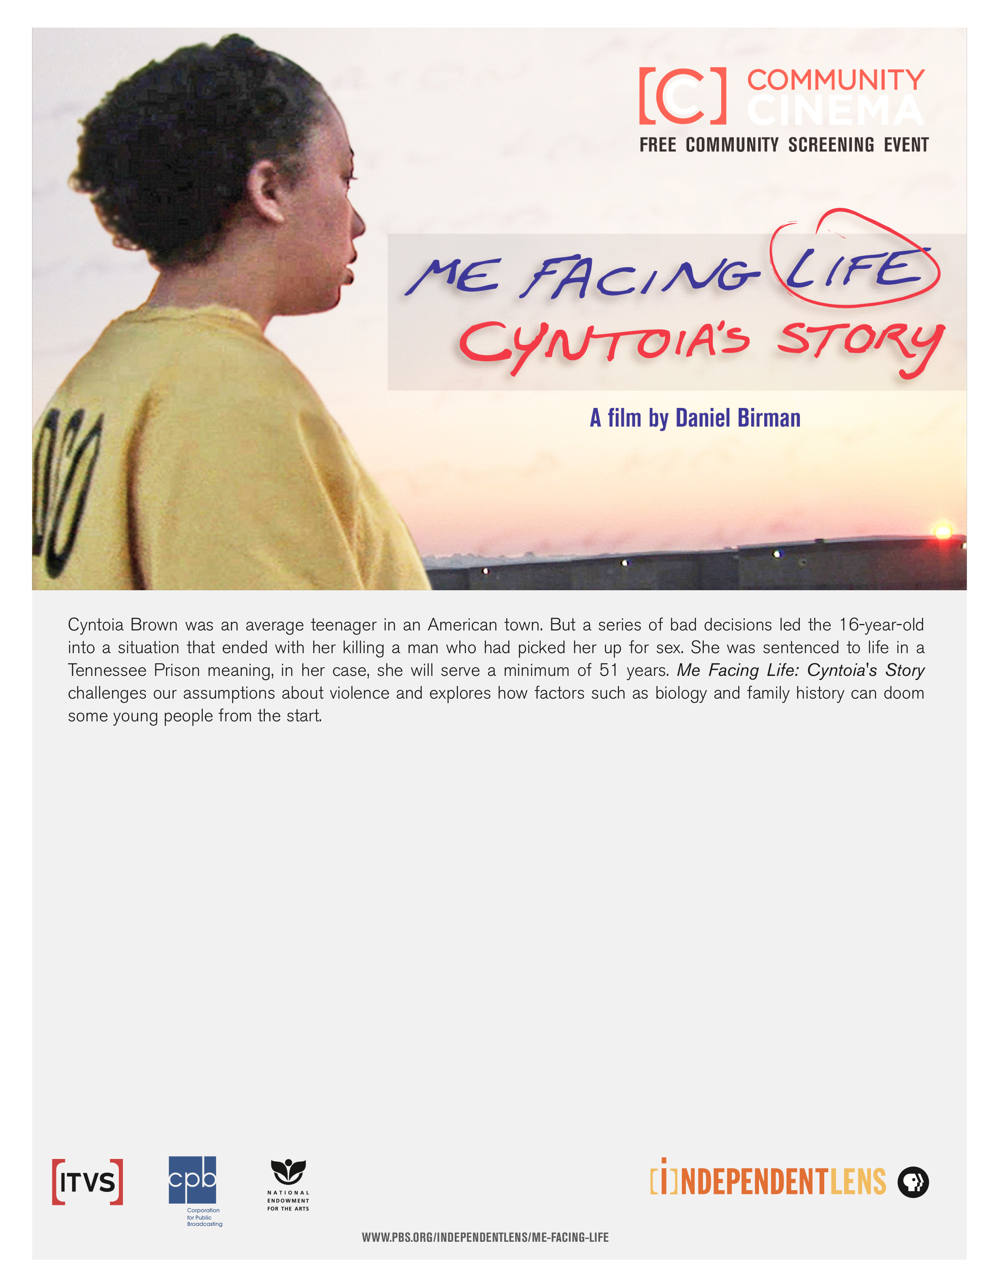
Title goes here.

Text information goes here.

